CHANNELING SKINNY BOB
He's been here since 1947. Now he's talking.
Complete Monetization & Launch Strategy
YouTube • Website • Patreon • Merch • Community

The Concept
Channeling Skinny Bob is the only ongoing record of one extraterrestrial's firsthand account of life on Earth since the mid-20th century. Every episode, every document, every transmission is filtered through the perspective of a being who was present for all of it — the Cold War, the cover-ups, the contacts you were never meant to know about.

Bob didn't choose to crash here. But after 77 years among humans — watching, listening, remembering — he has things to say.

The Golden Rule
Bob is never a character being performed — he is a witness being channeled. Every piece of content, every product description, every Patreon tier should feel like it's coming from something that has 77 years of patience and perspective. That's what separates this from every other UFO channel.

Monetization Strategy
The flywheel: YouTube drives traffic → website captures emails and members → Patreon funds deeper content → deeper content creates loyalty → loyal community shares videos → back to YouTube. Nothing is a dead end.

Channel | Method | Est. Monthly Potential
YouTube | Ad revenue (YPP) + Memberships + Super Thanks | $200–$2,000+
Patreon | 5-tier membership system | $500–$10,000+
Merch | Print-on-demand (Printful/Printify) | $300–$3,000+
Website | Digital downloads, paywalled archive, newsletter | $200–$2,000+
Podcast | Spotify/Apple subs + dynamic ads | $100–$1,000+
Sponsorships | UFO/paranormal brands, VPNs, prep brands | $500–$5,000+
Digital Products | Bob Files book, courses, lore packs | $300–$3,000+

YouTube (Foundation Layer)
- YouTube Partner Program — ad revenue once you hit 1,000 subs / 4,000 watch hours
- YouTube Memberships — tiers like Contactee, Believer, Inner Circle with early access and exclusive Bob transmissions
- Super Thanks / Super Chat — especially powerful during live 'transmissions' or Q&A streams where Bob 'channels' answers
- YouTube Shopping — link merch directly in videos

Patreon Membership Tiers

Tier | Name | Price | Key Perks
1 | Observer | $3/mo | Early video access, patron feed
2 | Contactee | $7/mo | Exclusive Bob Transmissions (lore drops)
3 | Cleared | $15/mo | Deep-dive reports, extended video cuts, Archive access
4 | Inner Circle | $30/mo | Monthly live Q&A, voice messages from Bob
5 | The 1947 Council | $75/mo | Name in credits, personalized Bob message, story input — only 47 spots

Merchandise
Wearables
- Minimalist Bob silhouette t-shirts and hoodies
- 'I Survived 1947' retro-style shirts
- 'He Never Left' caps
- Bob's face as a subtle embroidered patch

Stickers & Prints
- Bob sticker packs (perfect impulse buy, $5–$12)
- Retro-style 'Classified' posters with Bob imagery
- Art prints — Bob looking at Earth landscapes, in a diner booth, stargazing

Novelty / Conversation Pieces
- 'Bob's Field Guide to Earth Humans' — a funny/dark zine or book
- Enamel pins — hugely popular in alt/niche communities
- A Skinny Bob bobblehead (premium, limited run of 47)

Functional Items
- Skinny Bob tote bags
- 'Crash Site 1947' mugs
- Phone cases

Use Printful or Printify (print-on-demand, no inventory risk) integrated with Shopify or Etsy.

Digital Products & Content
- 'The Bob Files' — serialised digital book written from Bob's POV. Sell as episodes or full download ($9–$29)
- A Companion Course — 'The History of Contact' as a structured course (Teachable or Gumroad) — $49–$99
- Lore Packs — deep-dive PDFs on Roswell, Rendlesham, Phoenix Lights told from Bob's perspective
- An Interactive Timeline — paid web feature: Bob's annotated history of contact events since 1947

Sponsorships & Brand Deals
Once you have an audience, these niches sponsor heavily:
- UFO/paranormal documentary platforms (Gaia, Curiosity Stream)
- VPN companies (huge in the 'hidden knowledge' niche)
- Preparedness / survival brands
- Telescope and night-sky equipment brands
- Book publishers in the sci-fi/nonfiction space

Gamification & Community
- A Discord server with lore channels, debate rooms, 'classified' channels unlocked by Patreon tier
- ARG elements (Alternate Reality Game) — hidden messages in videos, coded transmissions on the website that fans decode together. This drives massive organic sharing.
- Fan submissions — 'Send Bob your contact story' — creates UGC content for free

The '47' Motif
The number 47 is your brand number. 47 council spots. 1947. Use it everywhere — limited runs of 47, 47-second teasers, April 7th as a 'transmission day.' It becomes part of the mythology.

Website Architecture
The website is where you build the universe — and charge for access to it. The recommended platform is Ghost CMS, which has built-in membership tiers, paywall functionality, and a newsletter system all in one.

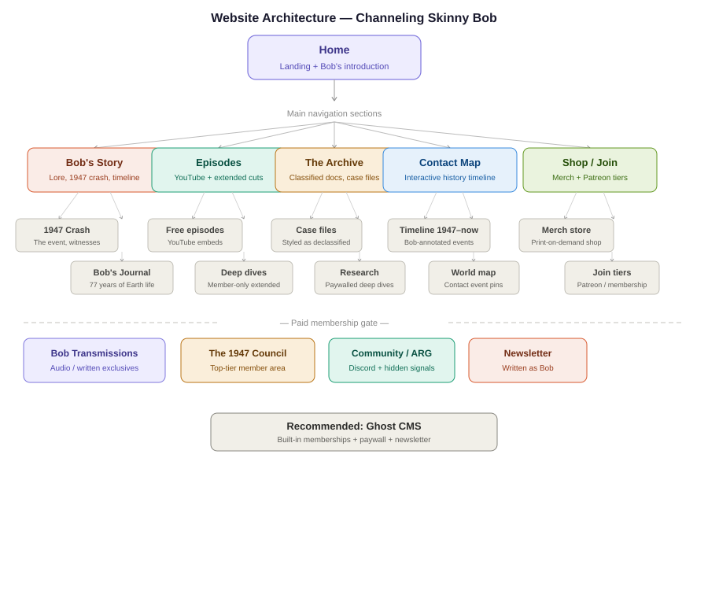

Main Navigation Sections
Bob's Story
The lore hub. The 1947 crash, the timeline, Bob's 77 years of Earth life. This is your mythology engine. Every other section references back here.

Episodes
YouTube videos embedded alongside deeper companion articles. Free episodes for everyone; extended cuts and deep dives behind the membership gate.

The Archive
A subscriber-only section styled as a classified document library. Case files, encounter reports, Bob's annotated versions of real declassified documents. This is the core paid content product.

Contact Map
An interactive world map and timeline of historical contact events since 1947, annotated by Bob. 30+ events by the end of the 90-day launch. Starts free, premium features behind paywall.

Shop / Join
Merch store (Printful integration) plus the Patreon/membership tier selection page. These should feel like the same journey — joining is buying into the world.

Patreon Page Copy

Page Title & Tagline
Channeling Skinny Bob
He's been here since 1947. Now he's talking.

About Section
Bob didn't choose to crash here. But after 77 years among humans — watching, listening, remembering — he has things to say.

Channeling Skinny Bob is the only ongoing record of one extraterrestrial's firsthand account of life on Earth since the mid-20th century. Every episode, every document, every transmission is filtered through the perspective of a being who was present for all of it. The Cold War. The cover-ups. The contacts you were never meant to know about.

On YouTube, we surface the stories. Here, we go deeper.

Your support keeps the archive open.

Tier Copy

Observer — $3/mo
“You’ve noticed something.”
Early access to all YouTube episodes before public release. A small act of acknowledgment. Bob notices.

Contactee — $7/mo
“You’ve been chosen for more.”
Everything above, plus exclusive written transmissions — short dispatches written directly from Bob’s perspective. Lore drops. Details that don’t make it to video. The texture of 77 years.

Cleared — $15/mo
“Your file has been updated.”
Full access to The Archive — extended deep-dive reports, annotated case files, the real story behind each episode. Think of it as the classified version of everything we publish.

Inner Circle — $30/mo
“You’ve been briefed.”
Monthly live sessions. Direct Q&A. Voice messages from Bob. You’re not just a viewer anymore — you’re part of the record.

The 1947 Council — $75/mo
“You were there.”
Your name in every episode’s credits. A personalised message from Bob. You help shape where the story goes next. Only 47 spots. (You know why.)

90-Day Content Calendar
Three phases — Signal, Depth, Community — each building on the last. Every week runs four parallel streams: YouTube, Website, Patreon, and Social/Teaser.

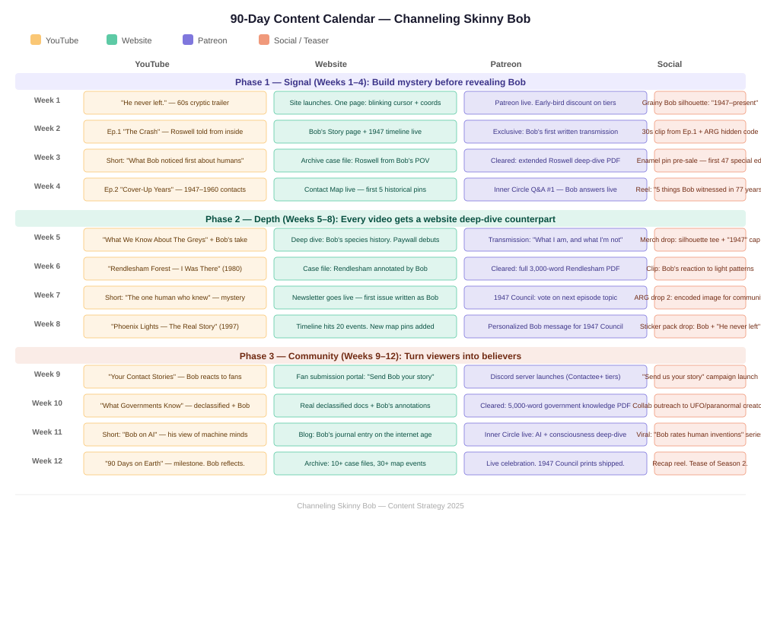

Phase 1 — Signal (Weeks 1–4)
Build mystery before revealing Bob. Don't explain — tease. The ARG begins in week 2 with a hidden code in a caption. The goal is to create a sense that something real is being uncovered.
- Week 1: Site launches. Cryptic trailer. Patreon goes live.
- Week 2: Episode 1 drops. Bob's Story page live. First written transmission for patrons.
- Week 3: Short video. Roswell case file in the Archive. Enamel pin pre-sale (first 47 = special edition).
- Week 4: Episode 2. Contact Map launches. First Inner Circle Q&A.

Phase 2 — Depth (Weeks 5–8)
Establish the lore engine. Every YouTube video now has a corresponding deep-dive article on the website. The paywall section opens. Newsletter launches.
- Week 5: The Greys episode. Bob's species history deep-dive. Merch drop.
- Week 6: Rendlesham episode. Annotated case file for Cleared members.
- Week 7: Mystery short. Newsletter launches written as Bob. ARG drop 2.
- Week 8: Phoenix Lights episode. Timeline hits 20 events. Personalized Bob messages for 1947 Council.

Phase 3 — Community (Weeks 9–12)
Turn viewers into believers. The audience becomes part of the story. Discord launches, fan submissions go into the show, collaborations with other creators begin.
- Week 9: Fan contact stories episode. Submission portal live. Discord launches.
- Week 10: Government knowledge episode. Real declassified docs + Bob's annotations.
- Week 11: Bob on AI. Viral short series: 'Bob rates human inventions.'
- Week 12: 90-day milestone. Council prints ship. Season 2 teaser.

Key Principles

Bob is a witness, not a character
Every piece of content should feel like it's coming from something that has 77 years of patience and perspective. He never reacts with surprise — he reacts with recognition.

The ARG is your secret weapon
Hidden codes in captions, coordinates that lead somewhere, a Discord channel that unlocks mid-season — this is free marketing. The internet hunts these things. One good ARG moment can go viral on its own.

The '47' motif
47 council spots. 1947. Use it everywhere — limited runs of 47, 47-second teasers, April 7th as a 'transmission day.' It becomes part of the mythology.

Platform stack recommendation
- YouTube — primary content and audience growth engine
- Ghost CMS — website, archive, newsletter, membership
- Patreon — fan funding (or replace with Ghost's built-in if preferred)
- Printful + Etsy/Shopify — merch (no inventory)
- Discord — community hub (Patreon integration for tier gating)

Channeling Skinny Bob — Strategy Document
He never left. Now he speaks.

